Report on Educational Field Trip to Bordowa, Nagaon:
An educational field trip to Bordowa, Nagaon was organized on 18th April 2026 by the Departments of Assamese, Economics, Philosophy & Political Science in Collaboration with Research Cell of Beltola College. The primary objective was to provide students with first-hand exposure to the historical, cultural, and philosophical heritage associated with Srimanta Sankaradeva, the 15th–16th century polymath and Vaishnavite saint of Assam.The trip was attended by faculty members and students from all four organizing departments. A total of 50 participants joined the excursion.
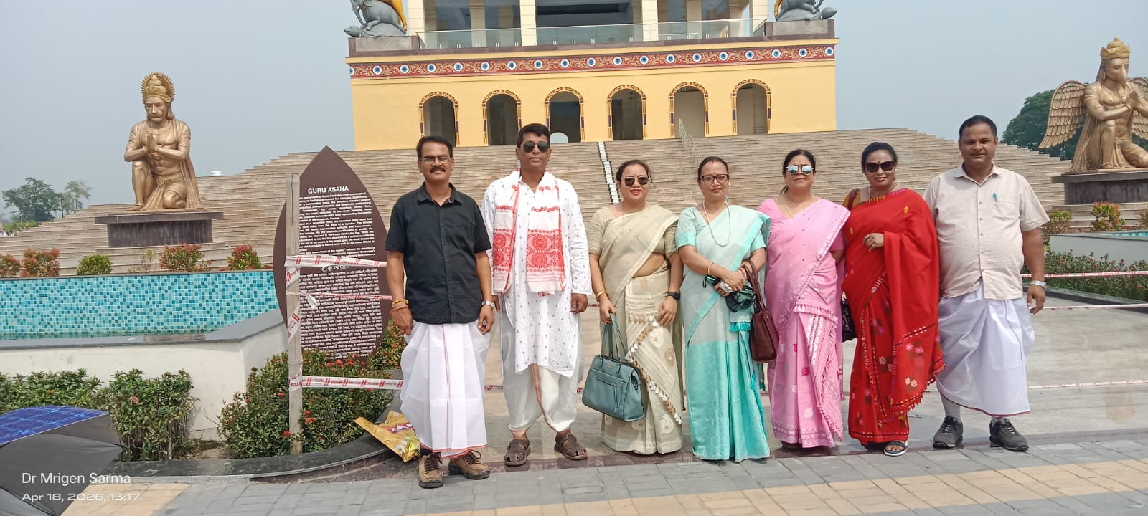The group visited key historical and religious sites at Bordowa Than, including: The Kirtan Ghar and Manikut The sacred pond Akashi Ganga and other monuments within the Bordowa Than complex. The visit enabled students to connect classroom learning with tangible heritage. It deepened their understanding of Assam’s neo-Vaishnavite movement, medieval Assamese literature, political thought, and socio-religious philosophy. Interactions with local guides also provided insights into the continuing cultural legacy of Sankaradeva.

The field trip was successfully conducted and achieved its academic objectives. It fostered interdisciplinary learning and strengthened students’ appreciation for Assam’s historical and cultural identity. The departments extend gratitude to the college authority for supporting the excursion and to the Bordowa Than Management Committee for their cooperation.